2022
CLASS OF
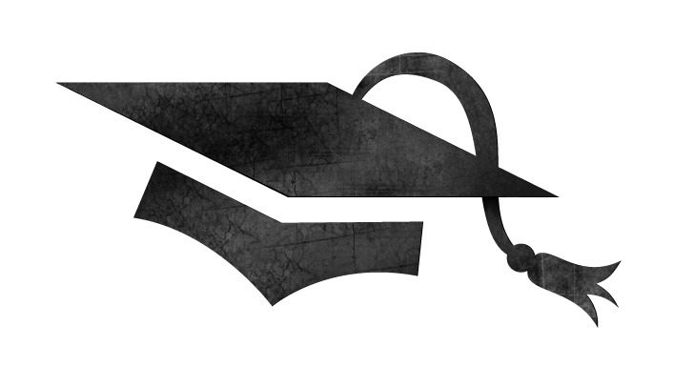
2022
CLASS OF
Please join us for the
Please join us for the
Graduation of our son/daughter

Type your student’s name here

from LiFT Academy/University

Friday, the 18th of May ?, 2022
at 9:30 a.m.

Oakhurst United Methodist Church
13400 Park Blvd
Seminole, FL 33776

Graduation of our son/daughter

Type your student’s name here

from LiFT Academy/University

Friday, the 18th of May ?, 2022
at 9:30 a.m.

Oakhurst United Methodist Church
13400 Park Blvd
Seminole, FL 33776

